Journal of New Materials for Electrochemical Systems
Vol., No., Month, Year, pp. **-**

Journal homepage: http://iieta.org/journals/jnmes

Instructions for Preparing Papers for Journal of New Materials for Electrochemical Systems
Aaa Surname^{1*}, Bbb B. Surname², Ccc C.C. Surname³

¹ Affiliation, address
² Affiliation, address
³ Affiliation, address

Corresponding Author Email:
Copyright: ©2024 The author(s). This article is published by IIETA and is licensed under the CC BY 4.0 license (http://creativecommons.org/licenses/by/4.0/).
https://doi.org/10.18280/jnmes.xxxxxx |  | ABSTRACT
Received:  Revised:  Accepted:  Available online: |  | Detailed instructions for preparing your paper submitted to Journal of New Materials for Electrochemical Systems are given as follows. Please be responsible for the quality and appearance of your work. It’s strongly recommended that you directly type over the template or just cut and paste from another document and use markup styles. Please keep in mind all the way through the preparation: do not modify page setup in this template, such as font, line spacing, margin, uppercase and lowercase, and the order of sections. The abstract section is mandatory, with a word limit of 200 words. The purpose, methodology, results & conclusions, and implications should be summarized here. Avoid inserting any reference in this section. In the Keywords section, please enter words or phrases in alphabetical order. There is a maximum of 8 keywords.
Keywords:
key word 1, key word 2, key word 3, key word 4, key word 5, key word 6, key word 7, key word 8
(no more than 8 keywords)

NOMENCLATURE

Each paper should have a separate nomenclature section that lists in detail and unambiguously all the symbols used in the text and their definitions. Do not use the same symbol for two or more different meanings or definitions; similarly, do not use more than one symbol for one variable/parameter. Each dimensional symbol must have SI units mentioned at the end. All dimensionless groups and coefficients must be indicated as dimensionless after their definitions. All Latin symbols (dimensional and dimensionless) should be listed in an alphabetic order. All Greek symbols follow the Latin symbols. Subscripts and superscripts follow Greek symbols and should be identified by a minor heading. Symbols that cannot be typed should be entered in black ink. Symbols should be italicized throughout the text.
Please make a nomenclature originally in a table and then hide all the borders so that the symbol column and the meaning column can be aligned from the top down. A template for nomenclature is as follows.

NOMENCLATURE

B | dimensionless heat source length
CP | specific heat, J. kg⁻¹. K⁻¹
g  k | gravitational acceleration, m.s⁻²  thermal conductivity, W.m⁻¹. K⁻¹
Nu | local Nusselt number along the heat source
Greek symbols

α | thermal diffusivity, m². s-¹
β | thermal expansion coefficient, K⁻¹
φ | solid volume fraction
Ɵ | dimensionless temperature
µ | dynamic viscosity, kg. m⁻¹.s⁻¹
Subscripts

p | nanoparticle
f | fluid (pure water)
nf | nanofluid

Introduction

Throughout the main text, please follow these prescribed settings: 1) the font is mostly Times New Roman; 2) almost all the words are typed in 10 points; 3) each line throughout the paper is single-spaced; 4) in most cases, 10 pts spacing shall be left above and below any heading, title, caption, formula equation, figure and table.
As mentioned in the abstract section, it will be rather easy to follow these rules as long as you just replace the “content” here without modifying the “form”.

- PAGE SETUP

The book size should be in A4 (8.27 inches × 11.69 inches). Do not change the current page settings when you use the template.
The number of pages for the manuscript must be no more than ten, including all the sections. Please make sure that the whole text ends on an even page. Please do not insert page numbers. Please do not use the Headers or the Footers because they are reserved for the technical editing by editors.

- SECTION HEADINGS

The way that section titles and other headings are displayed in these instructions, is meant to be followed in your paper.

Level 1: Times New Roman, 10, bold, all letters capitalized, 20 pts spacing above heading and 10 pts below, Example: “3. SECTION HEADINGS”
Level 2: Times New Roman, 10, bold, only the first letter as well as proper nouns capitalized, 10 pts spacing above heading, 10 pts spacing below heading. However, when a Level 2 heading is directly above a Level 1 spacing, just leave 10 pts spacing between them instead of 20 pts. Example: “4.1 Paper title”.
Level 3: Times New Roman, 10, not bold, only the first letter as well as proper nouns capitalized, 10 pts spacing above and below heading. However, when a Level 3 heading is directly below a Level 2 heading, just leave 10 pts spacing between them instead of 20 pts. Example: “4.2.1 Name”
No more levels successive to Level 3 are allowed. If you must add some “Level 4” heading, just place it at the beginning of a paragraph, underline it, and follow it with a full stop and immediately the text. For example:

The heater tube. This device is used as the electrical resistance for providing heat input. D.C. voltage is applied at the…

Do not begin a new section directly at the bottom of the page, instead, move the heading to the top of the next page.

More details about Paper title and Author information

4.1 Paper title

Paper titles should be written in upper-case and lower-case letters, not all upper-case, e.g., “Instructions for preparing papers for Journal of New Materials for Electrochemical Systems”. Do not use capital letters for prepositions, articles or conjunctions unless one is the first word.
Avoid writing long formulas with subscripts in the title; short formulas that identify the elements are fine (e.g., “Nd–Fe–B”).

  - Author information

4.2.1 Name
Full names of authors are required. The middle name can be abbreviated.

4.2.2 Affiliation
Different affiliations shall be listed in separate lines. Do not insert any punctuation at the end of each affiliation. If all the authors are affiliated to the same organization, type that affiliation just once.

4.2.3 Superscripts
To match authors and their own affiliations, please insert numerical superscripts, i.e., ^{“1, 2, 3, 4 …”} followed by a space, after name and, correspondingly, before affiliation. If all the authors are affiliated to the same one organization, any number is no need.
Do not forget to denote the corresponding author with a superscript asterisk (*). You may offer emails of all co-authors. But in the final version of your manuscript, only one valid email of the corresponding author will be kept.

Math

5.1 Equations

- Tool: You are strongly recommended to use MathType (http://www.mathtype.com) to edit equations. Microsoft Equation Editor is also acceptable. (Insert | Object | Create New | Microsoft Equation or MathType Equation). “Float over text” should not be selected.
- Format: The size of equation is 10 pts. Remember to leave 10 pts spacing both above and below an equation. Set the equation flush left, without indenting it.
- Numbering: Make sure that placing and numbering of equations is consistent throughout your manuscript. References to the equations should be as Eq. (1). Make the number of an equation flush-right. For example:

(1)

  - Measurement units and numbers

Please use the SI set of units as much as possible. Wherever the application domain uses a different set of units widely, please minimize the use of non-standard units or non-standard symbols for those units. For example, the use of “a” for year (annum) is depreciated and the use of “y” is encouraged instead. Similarly, “h” should be used for hours instead of “hr” and “t” instead of “ton” or “tonne”. It is important to take care of the case in which the measurement units are typed. e.g. “Km” does not mean “kilometres”, but “Kelvin-meters”.
When providing numerical values followed by measurement units, please leave a regular space or non-breaking space between each value and the measurement unit. This also includes percentages and degrees Celsius (e.g. 42% or 35%, 234°C, 504 K). This rule also applies to the unit for litre, which is recommended to be capital “L”.
The authors are encouraged to render the numbers specifying the dot as a decimal separator and the comma as a thousand separator. Please use the British style for numbers – i.e. 1,000,000 and not 1000000 or 1 000 000.

TABLES AND FIGURES

6.1 General

- Briefly and descriptively title each table and caption each figure. Place figure captions below the figures whereas table titles above the tables. Please do not include captions as part of the figures or put them in “text boxes” linked to the figures. Also, do not place borders around the outside of your figures.
- All the table titles and figure captions should be centered, Times New Roman font and 10 pts in size. Just capitalize the first letter of words, phrases and sentences which are included in tables and figures.
- Reference each table and figure within the text by writing: e.g., Table 1 or Figure 1 (instead of Tab. 1 or Fig. 1). If possible, place tables and figures in the order mentioned in the text, at top or bottom of page, as close as possible to text reference.
- Allow 10 pts spacing between the table title and the table (or between the figure and its caption). The equal spacing is allowed between the table or figure and the following text.

Tables

Words within a table should use 9 pts. The table number should be in bold type.
In general, if a table is too long to fit one page, the table number and heading should be repeated on the next page before the table is continued. Alternatively, the table may be spread over two consecutive pages (first an even numbered, then an odd-numbered page) turned by 90, without repeating the heading. Here is an example:

Table 1. Table title

Heading1 | Heading 2 | Heading 3
Table size | can be | edited
Notes: 1. If you must attach a note for further explaining some data in the table, please use 8 pts font size here. 2. If more than one note is to be attached, please number them with “1, 2, 3 …” and separate them with a period or a semicolon. 3. The right and left borders of the note area must be aligned in relation to those borders of the table above it no matter what the table size is. 4. Please distribute your notes evenly between the margins.

Figures

Please make sure that the captions are on the same page with the relevant figures and tables. Please keep captions short – taking preferably one line. If a caption is a complete sentence, place a period at the end of it. If not, then place no punctuation at the end.
Figures and captions must be centered. Any word, number, shape and symbol on figures must be discernible when the page zoom level stands at 120%. We suggest that you use one of the following Open Type fonts: Times New Roman, Helvetica, Arial, Cambria, and Symbol, when preparing your figures.
Various figures can be accepted. Several examples cited from papers published in previous IIETA journal issues are as follows. Please pay special attention to how much line spacing is allowed in different cases:

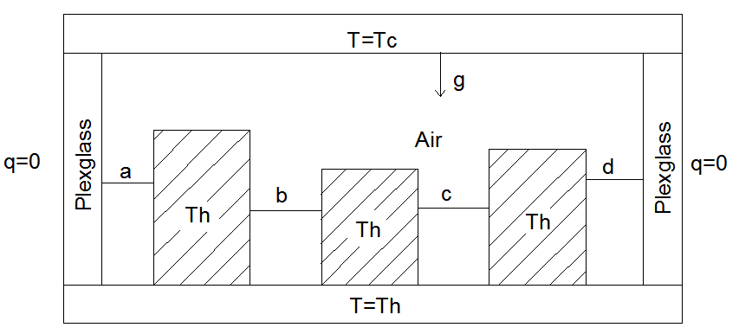

Figure 1. Cavity geometry

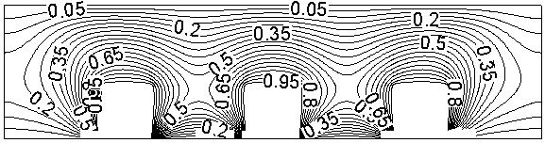

(a) Temperature field

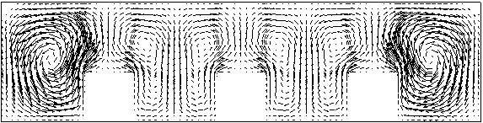
(b) Velocity vector field

Figure 2. Three heat sources

- CONCLUSIONS

It is mandatory to have conclusions in your paper. This section should include the main conclusions of the research and a comprehensible explanation of their significance and relevance. The limitations of the work and future research directions may also be mentioned. Please do not make another abstract.

acknowledgment

Acknowledgement section is not numbered and presented after the conclusion. Use the singular heading even if you have many acknowledgments. Avoid expressions such as “One of us would like to thank ...” Instead, write “This work is supported by the National Science Foundation (Grant numbers: xxxx, yyyy).”

REFERENCES

In order to give our readers a sense of continuity, we encourage you to identify in your papers the articles of similar research published in past issues of the journal. Please do a literature check of the papers published in the journal in recent years.
Literature included in your references list must all be mentioned in the text. Please number all the pieces of literature in the order of their appearance in the text and mark them with Arabic numerals in square brackets, such as [1], [2], [3]. Please do not make these numerals superscript either in the text or in the references list.
The digital object identifier (DOI) should be attached to the end of a reference if the reference has one indeed. You may find DOI at http://www.crossref.org/guestquery/#.
You may imitate the following examples to prepare your references:

- Bhoopal, N., Rao, D.S.M., Sireesha, N.V., Kasireddy, I., Gatla, R.K., Kumar, D.G. (2022). Modelling and performance evaluation of 18w PEM fuel cell considering H2 pressure variations. Journal of New Materials for Electrochemical Systems, 25(1): 1-6. https://doi.org/10.14447/jnmes.v25i1.a01
- Bejan, A. (2015). Constructal thermodynamics. Constructal Law & Second Law Conference, Parma, pp. S1-S8.
- Chen, W.K. (1993). Linear Networks and Systems. Wadsworth, Belmont, 123-135.
- Costa, T., Zarante, P., Sodré, J. (2013). Simulation of aldehyde formation in ethanol fuelled spark ignition engines. In: Sens, M., Baar, R. (eds) Engine Processes. Expert Verlag, Berlin.
- Bentley, R.E. (1998). Handbook of Temperature Measurement Vol. 3: The Theory and Practice of Thermoelectric Thermometry. Springer Science & Business Media.
- Williams, J.O. (1993). Narrow-band analyzer. Ph.D. dissertation. Department of Electronic Engineering, Harvard University, Cambridge, Massachusetts, USA.
- SIMUL8 Corporation. SIMUL8 – Process Simulation Software. http://www.simul8.com/, accessed on Jan. 17, 2015.
- Reber, E.E., Michell, R.L., Carter, C.J. (1988). Oxygen absorption in the earth’s atmosphere. Technical Report TR-0200 (4230-46)-3. Aerospace Corporation, Los Angeles, California, USA.
- Motorola Semiconductor Data Manual. (1989). Motorola Semiconductor Products Inc., Phoenix, USA.

NOMENCLATURE

Each paper should have a separate nomenclature section that lists in detail and unambiguously all the symbols used in the text and their definitions. Do not use the same symbol for two or more different meanings or definitions; similarly, do not use more than one symbol for one variable/parameter. Each dimensional symbol must have SI units mentioned at the end. All dimensionless groups and coefficients must be indicated as dimensionless after their definitions. All Latin symbols (dimensional and dimensionless) should be listed in an alphabetic order. All Greek symbols follow the Latin symbols. Subscripts and superscripts follow Greek symbols and should be identified by a minor heading. Symbols that cannot be typed should be entered in black ink. Symbols should be italicized throughout the text.
Please make a nomenclature originally in a table and then hide all the borders so that the symbol column and the meaning column can be aligned from the top down. A template for nomenclature is as follows.

NOMENCLATURE

B | dimensionless heat source length
CP | specific heat, J. kg⁻¹. K⁻¹
g  k | gravitational acceleration, m.s⁻²  thermal conductivity, W.m⁻¹. K⁻¹
Nu | local Nusselt number along the heat source
Greek symbols

α | thermal diffusivity, m². s-¹
β | thermal expansion coefficient, K⁻¹
φ | solid volume fraction
Ɵ | dimensionless temperature
µ | dynamic viscosity, kg. m⁻¹.s⁻¹
Subscripts

p | nanoparticle
f | fluid (pure water)
nf | nanofluid

APPENDIX

- Appendix. If there is an Appendix section in your paper, please place the section after Nomenclature and follow the format of the text body.
- Footnotes. It is recommended that footnotes be avoided.
- Permissions. You are responsible for making sure that you have the right to publish everything in your paper. If you use material from a copyrighted source, you may need to get permission from the copyright holder. You need to seek permission to use a figure or table if it has not been changed in any substantive way from the original or if it does not plot or compile data readily available to anyone. You need to seek permission to quote material if you use it in a way competitive with the original material, that is, if your use of the material will harm the rights of the original publisher and/or author. This criterion holds true regardless of the length of the quote. If the quoted material will not be used competitively, you need only to cite the original source. Please consult your own legal adviser if you have any questions about what may need permission.

